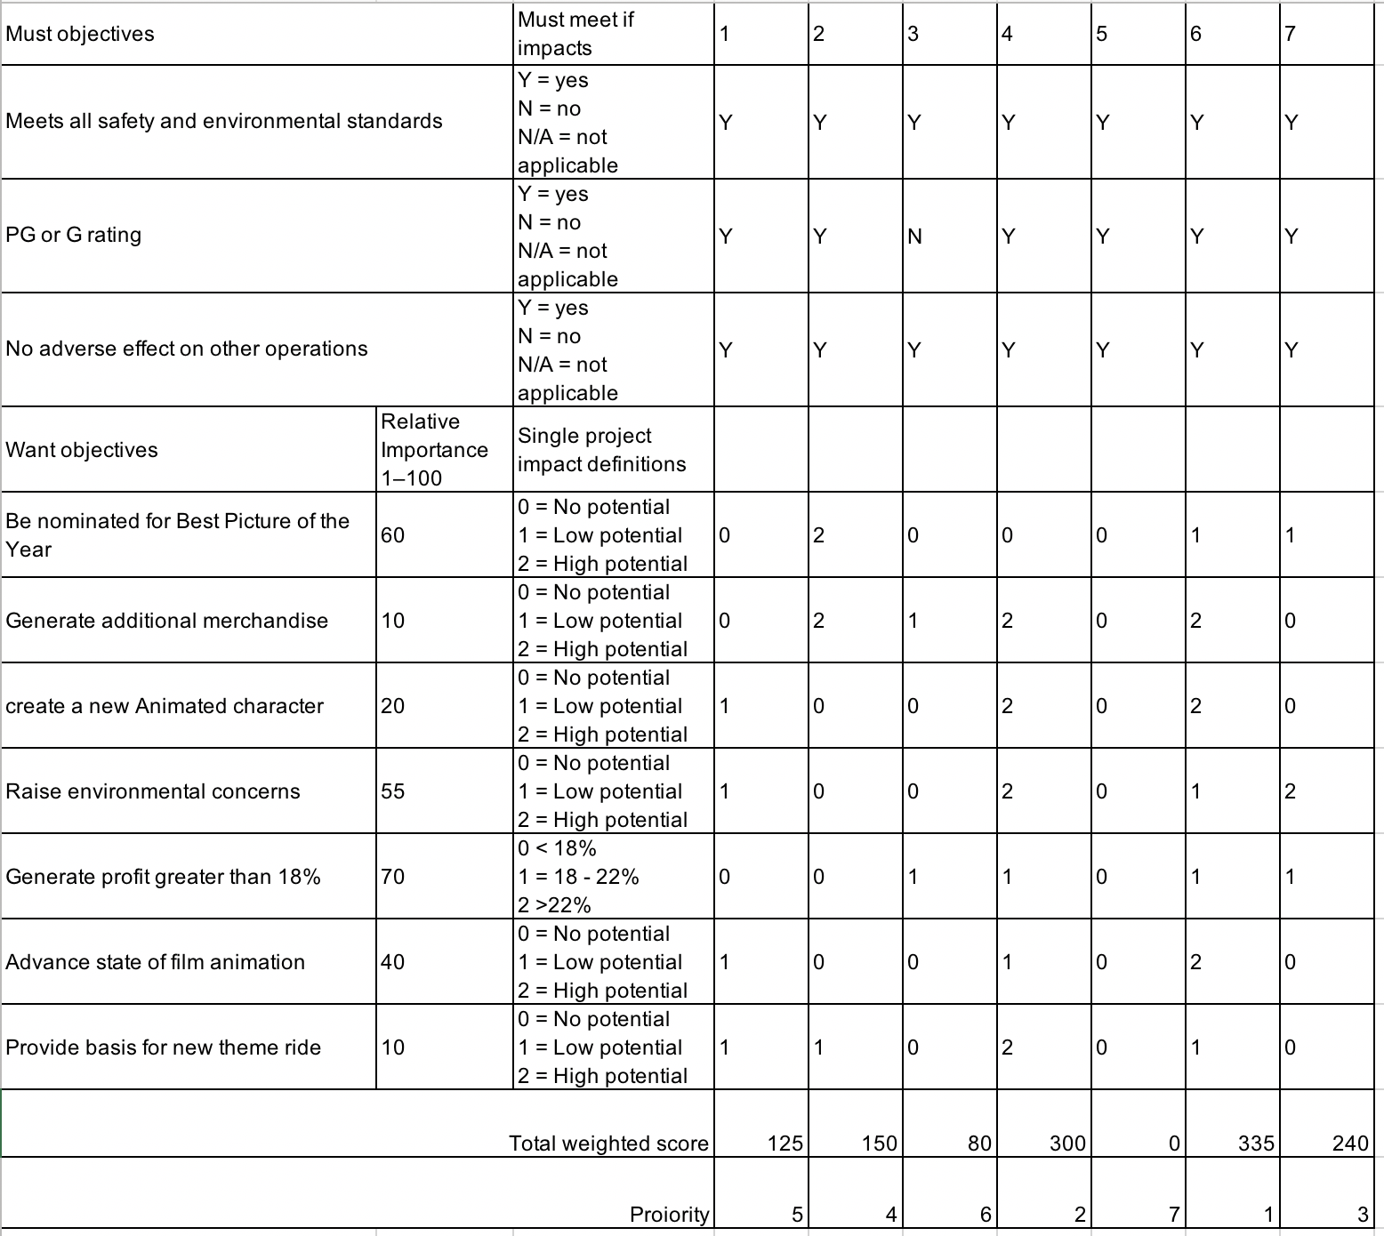After a few days of intense discussion, we finally reach an agreement about the priority of seven movie proposals, and from these days’ discussion , I find many useful pieces of information and I believed that a brief summary could be helpful for our further process, So as a PM, I am going to summarize what we have achieved in this part.

Firstly, some mistakes need to be careful.

1. Check the from before submit, some of our teammates use the wrong from and the rest of team followed.
2. Misunderstand about classification, some movie is not cartoon, but some of teammates still classify it as‘advance state of film animation’and ‘create a new animated charater’.

When it comes to the movie proposal 1, most of us reach an agreement about environment concerns and as it is a cartoon movie, so we both agree that it could create a new animated character. However, although there is a controversial about the new theme ride, thanks to Yuchen pointing out the misunderstanding of theme ride and give an example.

For the movie proposal 2, we all have no objection on the must objectives, but for the want objectives, firstly, Thanks to Yuchen for point out my misunderstanding about animation film, and most of us belived that the big-budget film with superstars has highest possibility to win the best picture of the year

For the movie proposal 3,the year of echo, we all agree with marking it as no PG or G rating, and the most objection part is ‘additional merchandise’.

For the proposal 4, we agree all must objectives, and also for all of our teammate belived that this animation film has high potential for generating additional merchandise and raise awareness of environment.

For the proposal 5, it seem like this type of movie are not very popular,we mark all as no potential.

For the proposal 6, the whole team gives this proposal a very high percentage of ‘high potential’in want objectives, Sui even give almost all high potential for the want objectives part, so there is no doubt that this proposal should be the first of our priority form.

For the proposal 7, ‘grand island’, for all the animation film of this project, it all related to the animal, which means that there are potential for those parts that related to the animation.

To conclude most of the ideas, we rank it depend on the most of our teammates’opinions and also mainly based on our discussion, so for those teammates who not active, please making your contribution for the follow task.

Tomorrow we will start the second part of discussion and for this part we have 3 days to go, hoping everyone in our team can be active and fully participant.

Cheers

Wanze Liu